A000-Mex-Veracruz-Figure-with Hat and Shawl-Black and Red-Terra cotta-600-800 CE

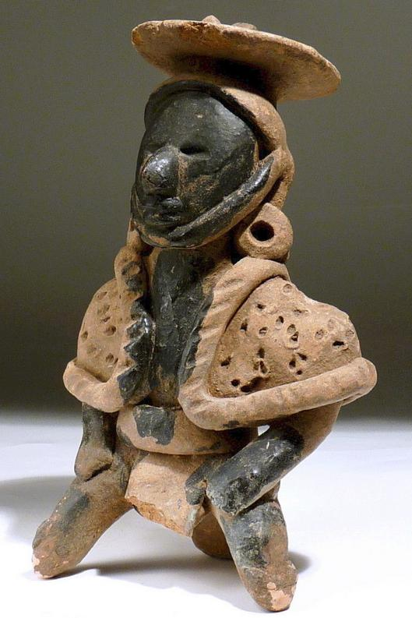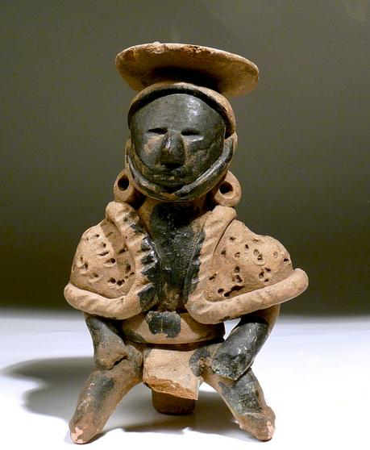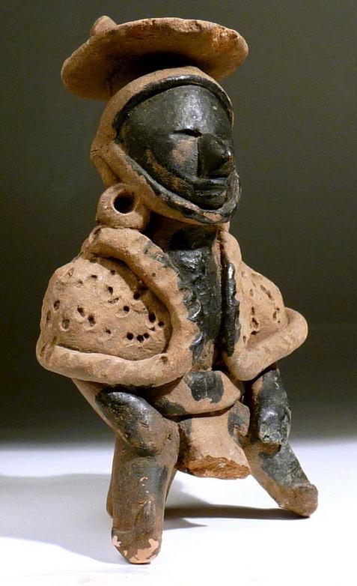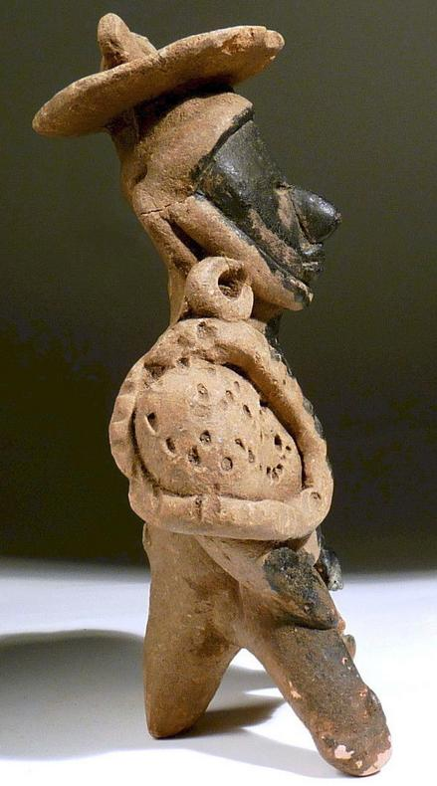

Case No.: 9

**Accession No.**

**Formal Label:** Mex-Veracruz-Figure-with Hat and Shawl-Black and Red-Terra cotta-600-800 CE

**Display Description:**

Handsome buff brown and black terra cotta of a sitting male shaman with slit eyes that suggest a trance state. This figure wears a disc-shaped headdress with a topknot and a chin strap, a cape with incised punctated texture that emulates fur that has a broad, rolled trim. A loincloth is secured with a waist belt.  A third support leg that suggests a seat incorporates a whistle feature. The head, chest and limbs are painted black. This is a striking piece of great eye appeal.

**LC Classification:**

**Date or Time Horizon:**

**Geographical Area: Veracruz**

**Map:**

**GPS coordinates:**

**Cultural Affiliation:**

**Media:** terra cotta and black paint

**Dimensions:** Height: 6-3/4 in. (17 cm

**Weight:**

**Condition:** The figure is intact as pictured but there is partial loss to part of topknot and the loincloth.

**Provenance:** EX Zeus Gallery with C.O.A.

**Discussion:**

**References:**